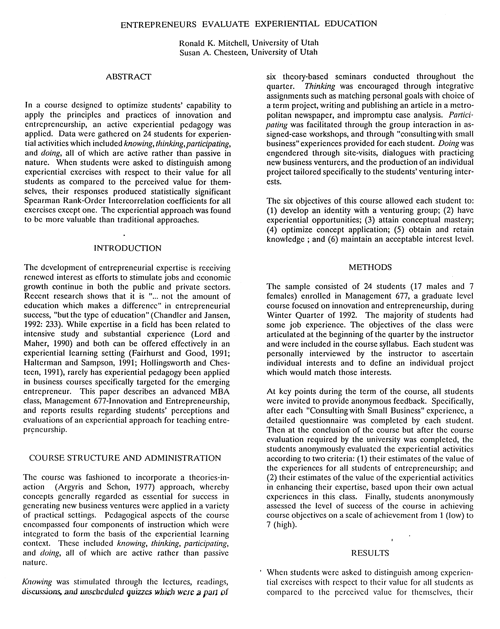

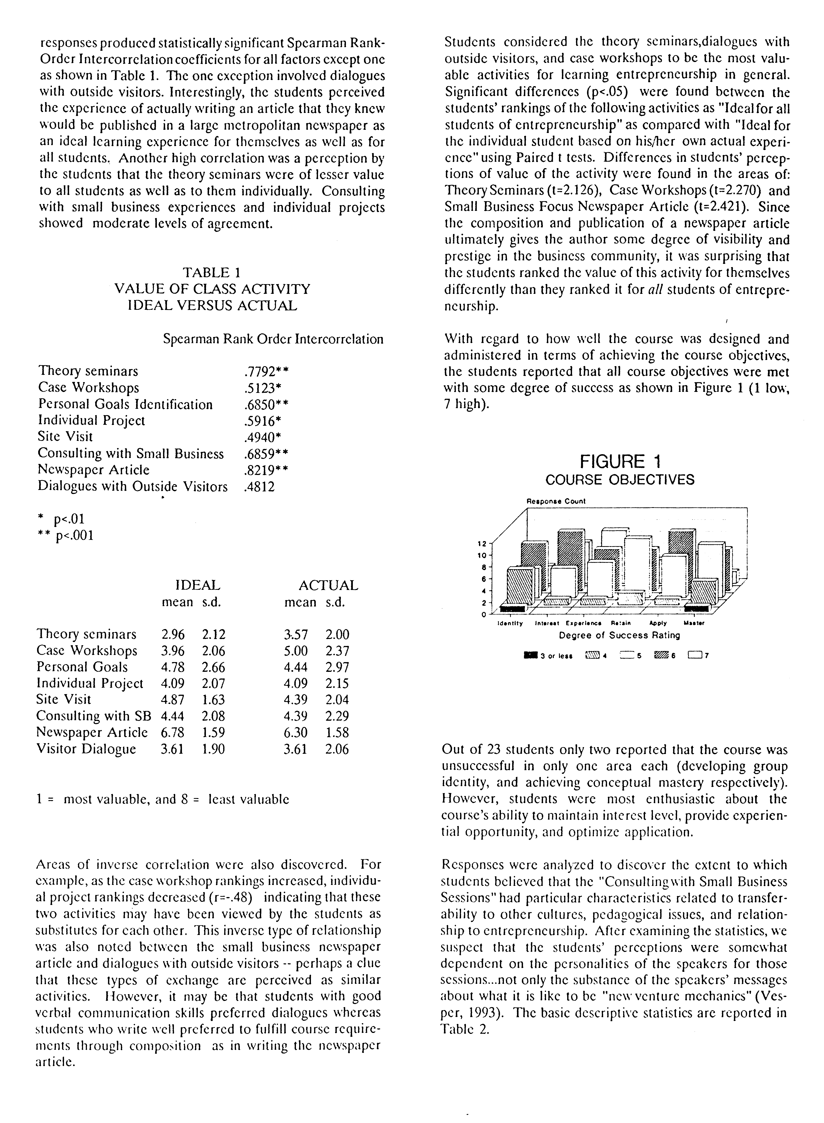
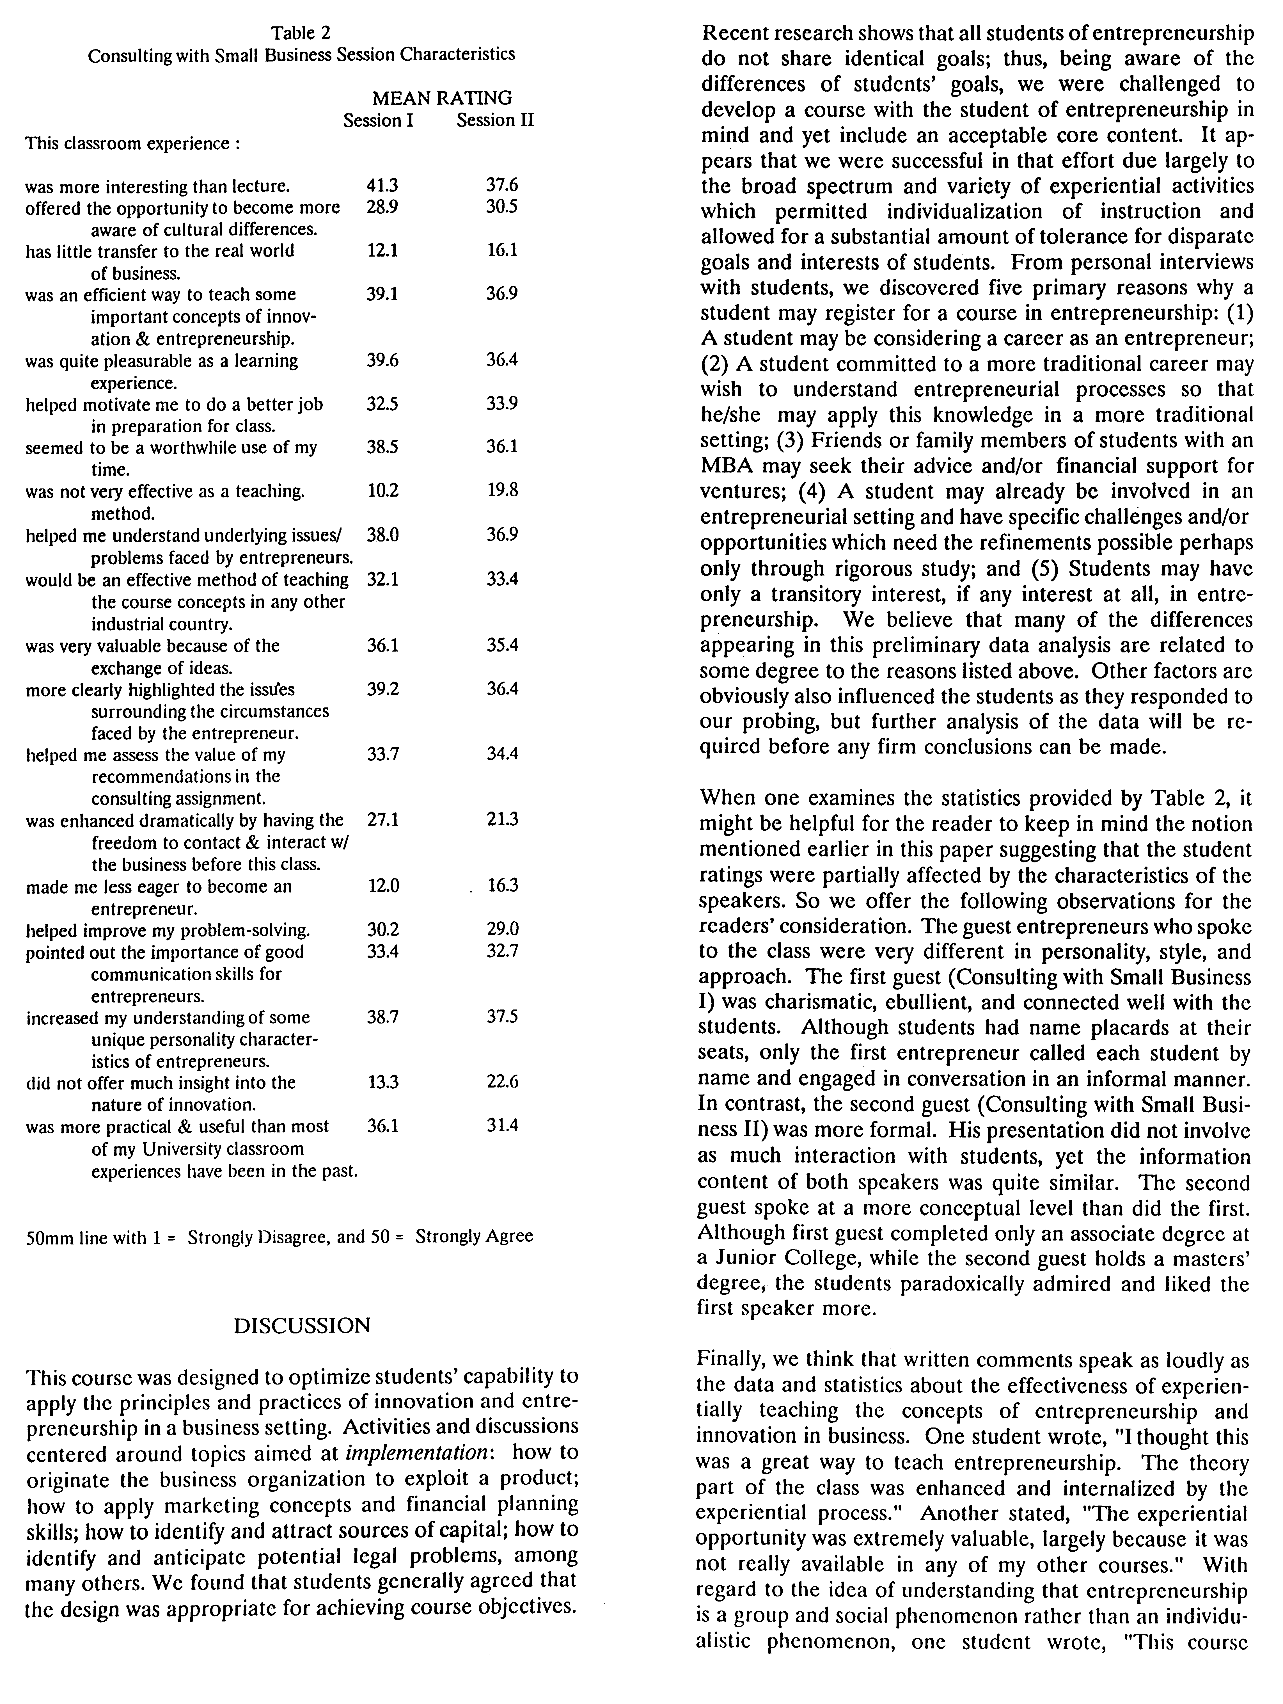
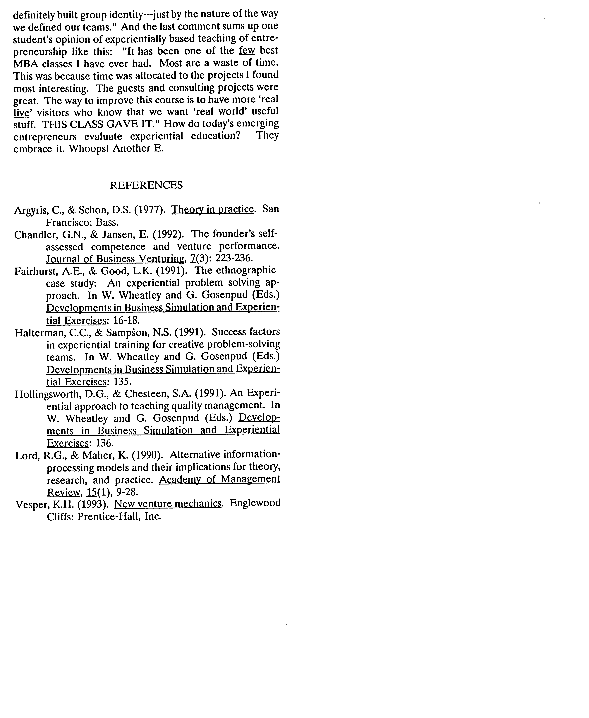
From: Mitchell, R.K., Chesteen, S.A. (1993). Entrepreneurs evaluate experiential education. Proceedings of the Association for Business Simulation and Experiential Learning Conference, 20: 82-85, Savannah, Ga., April, 1993.

