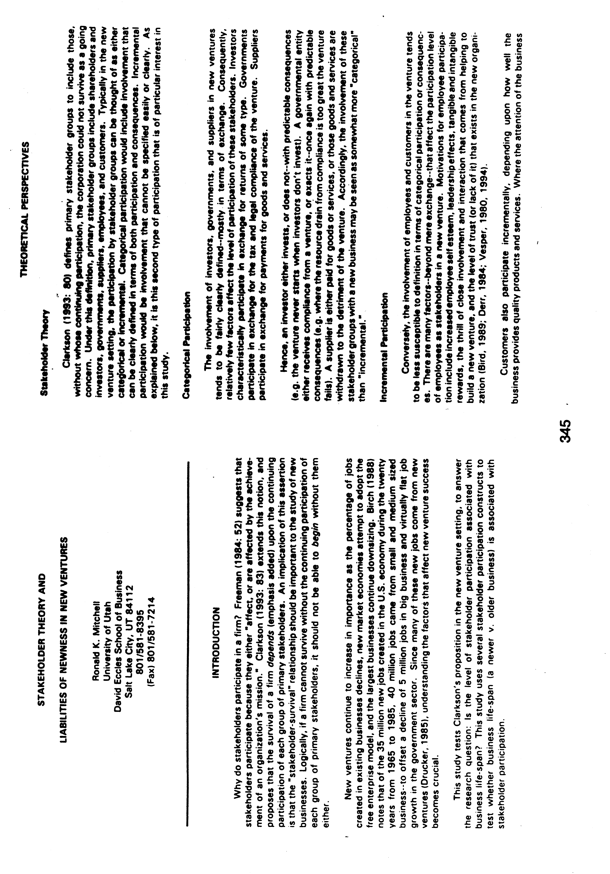
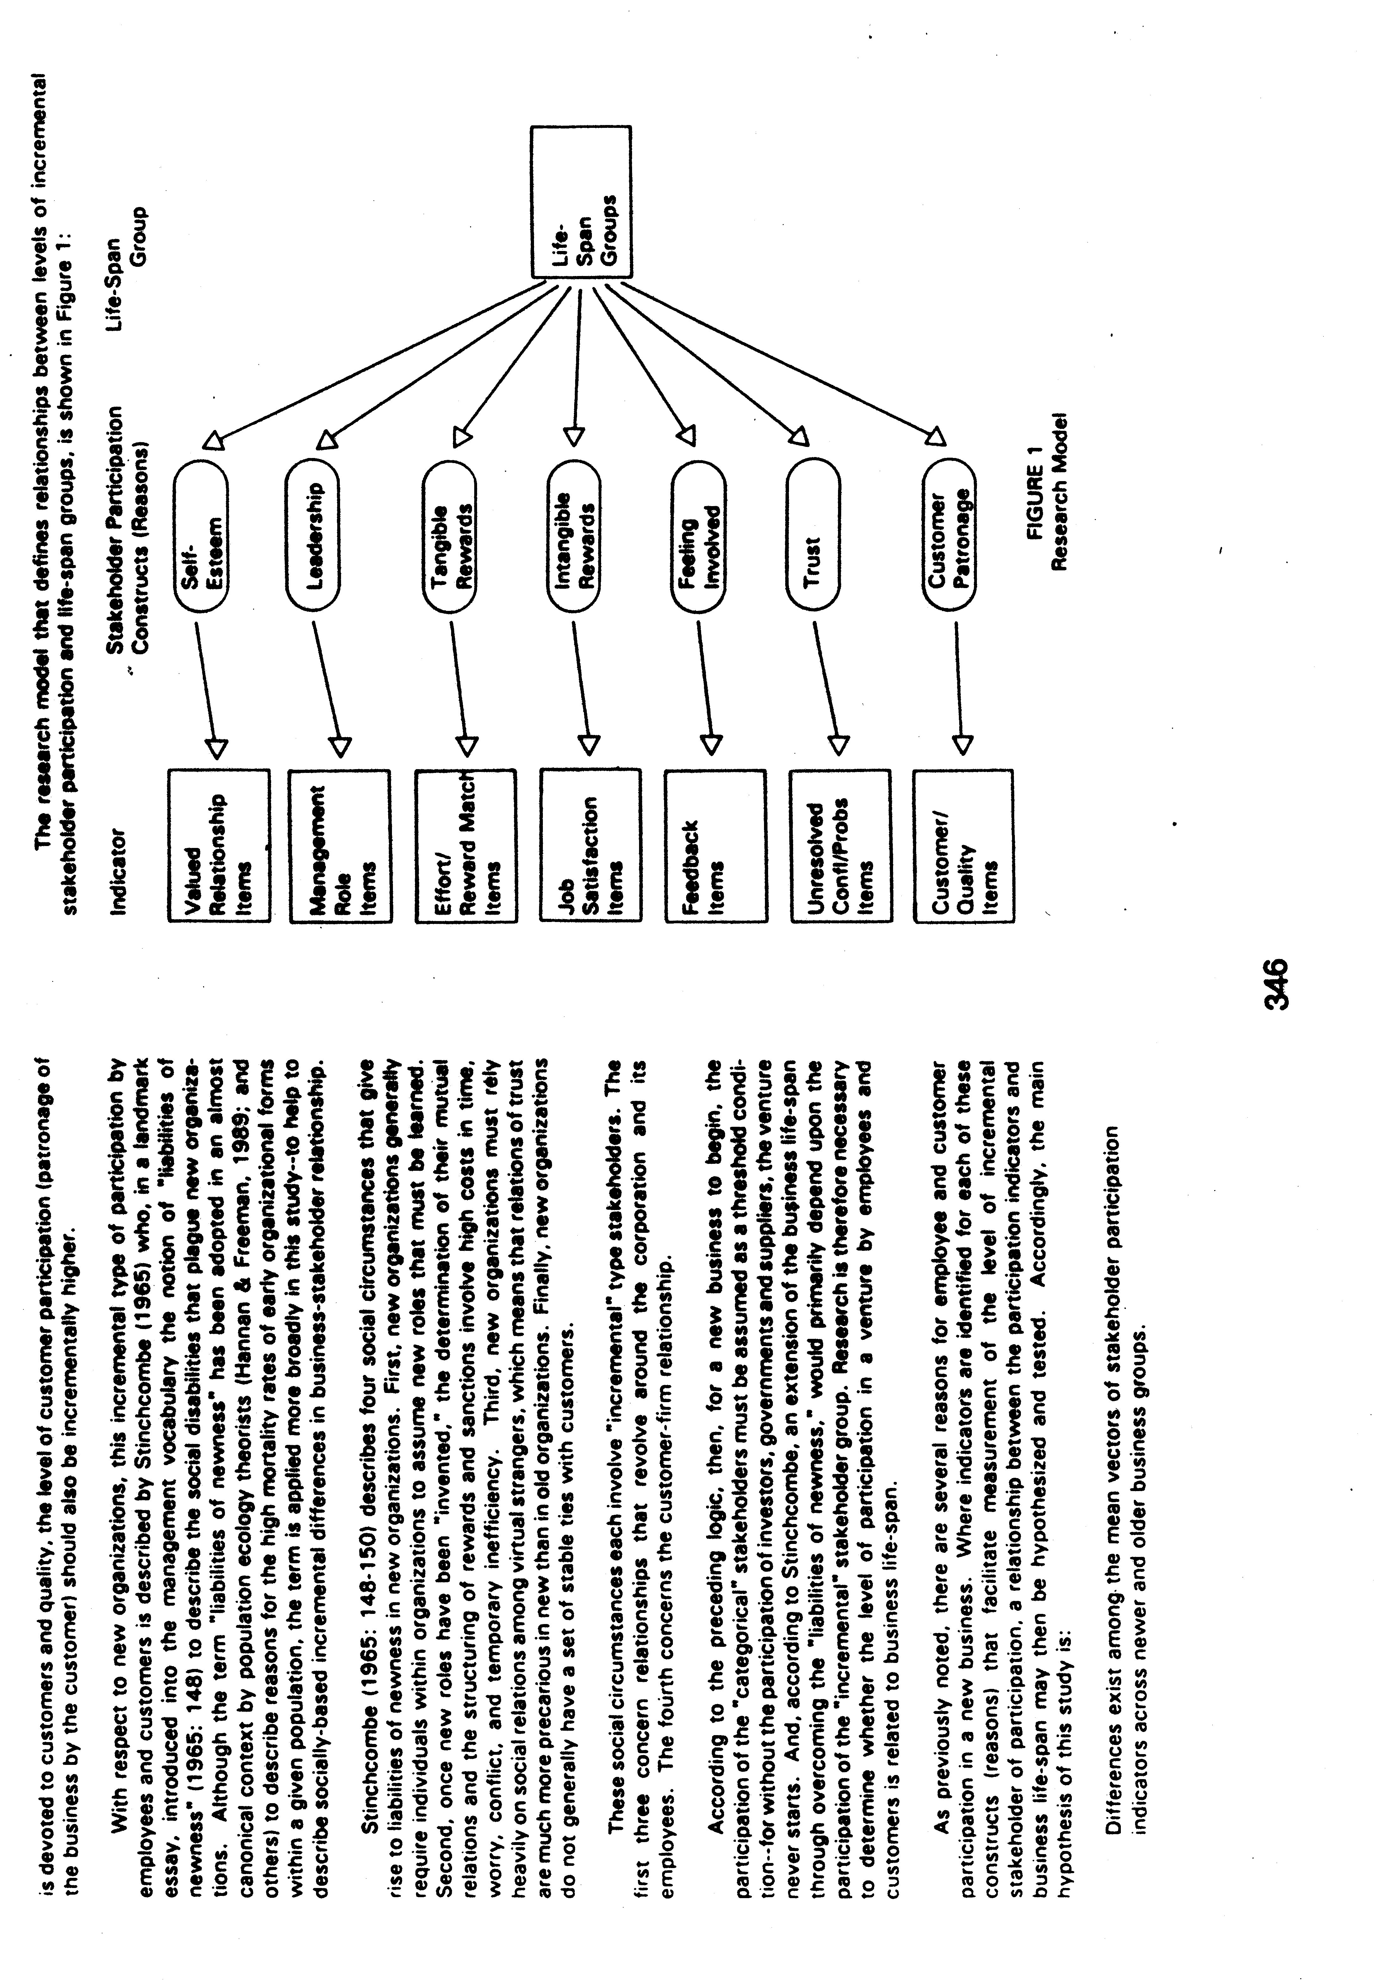
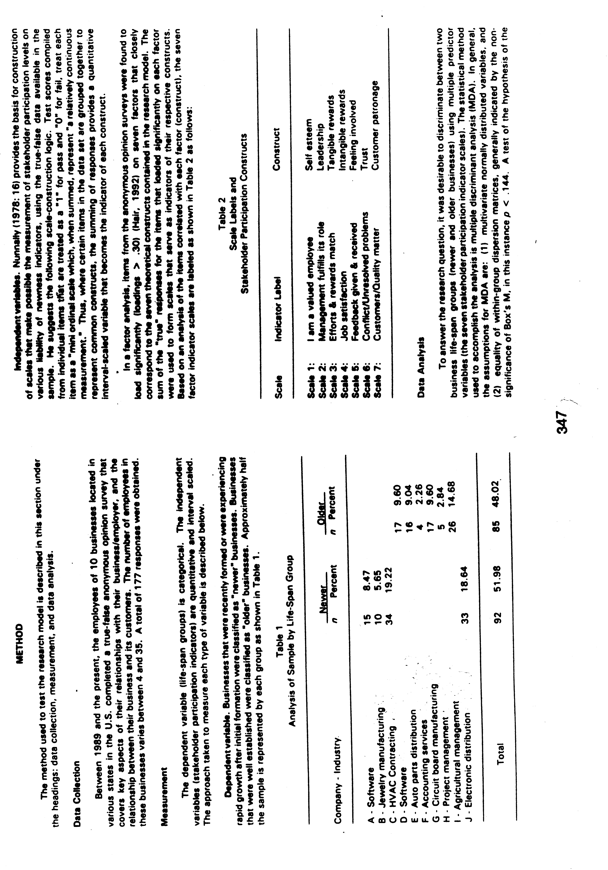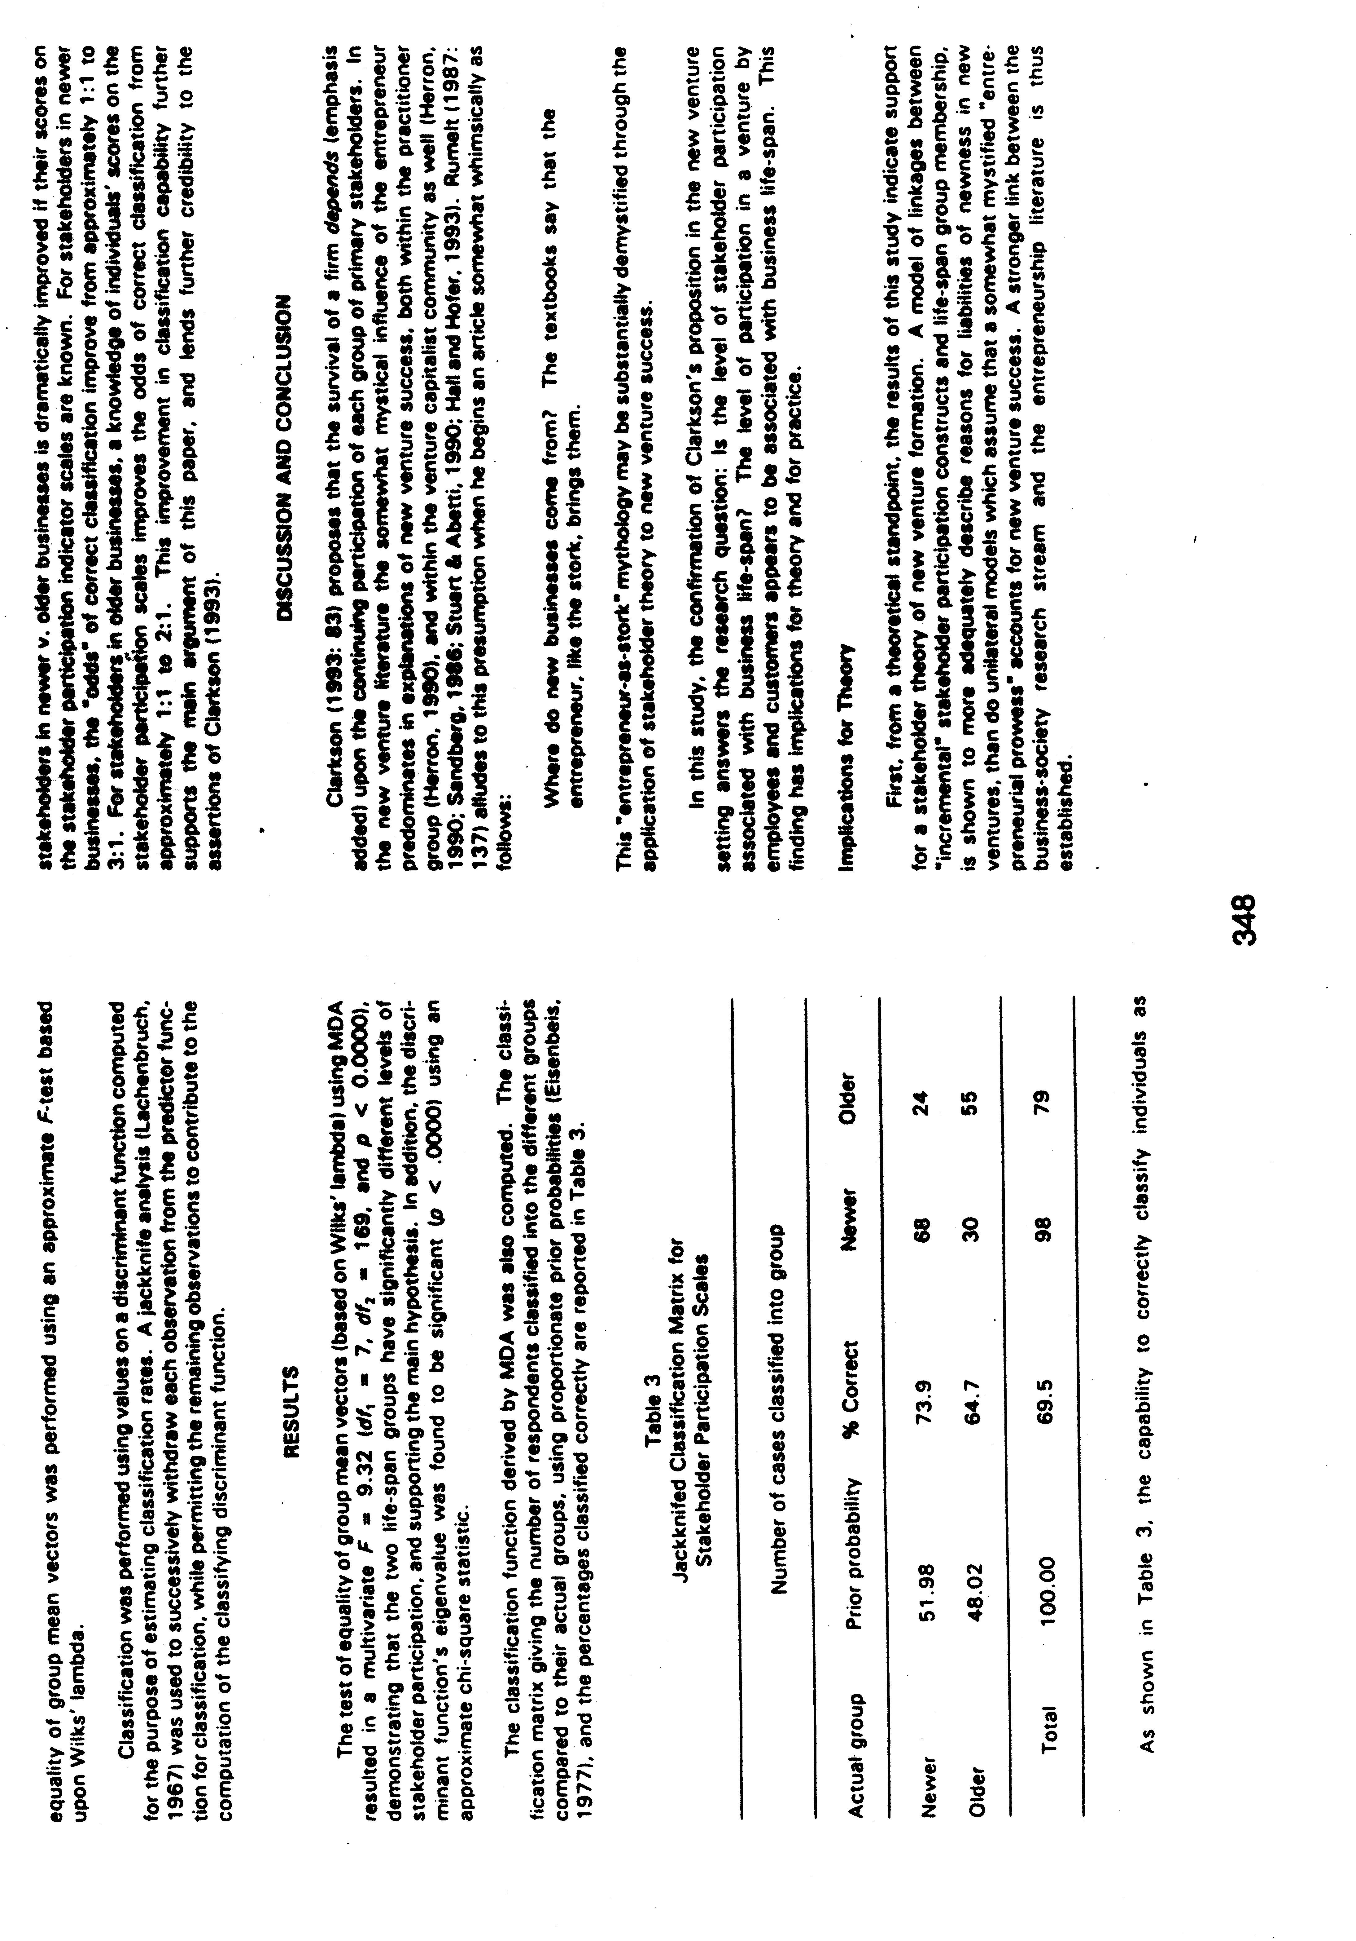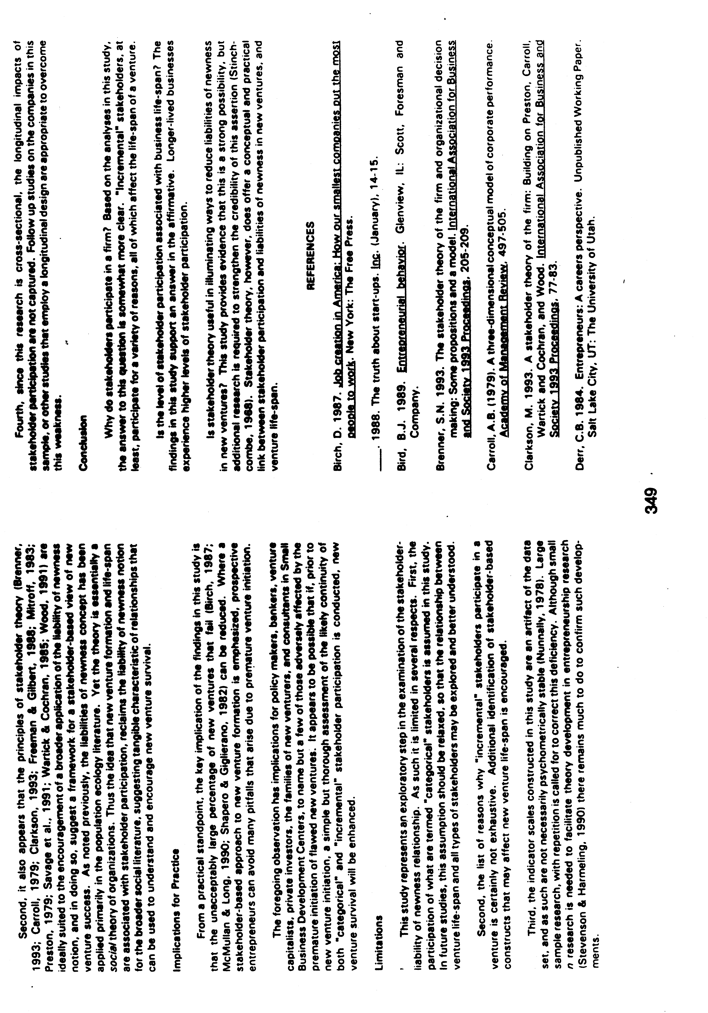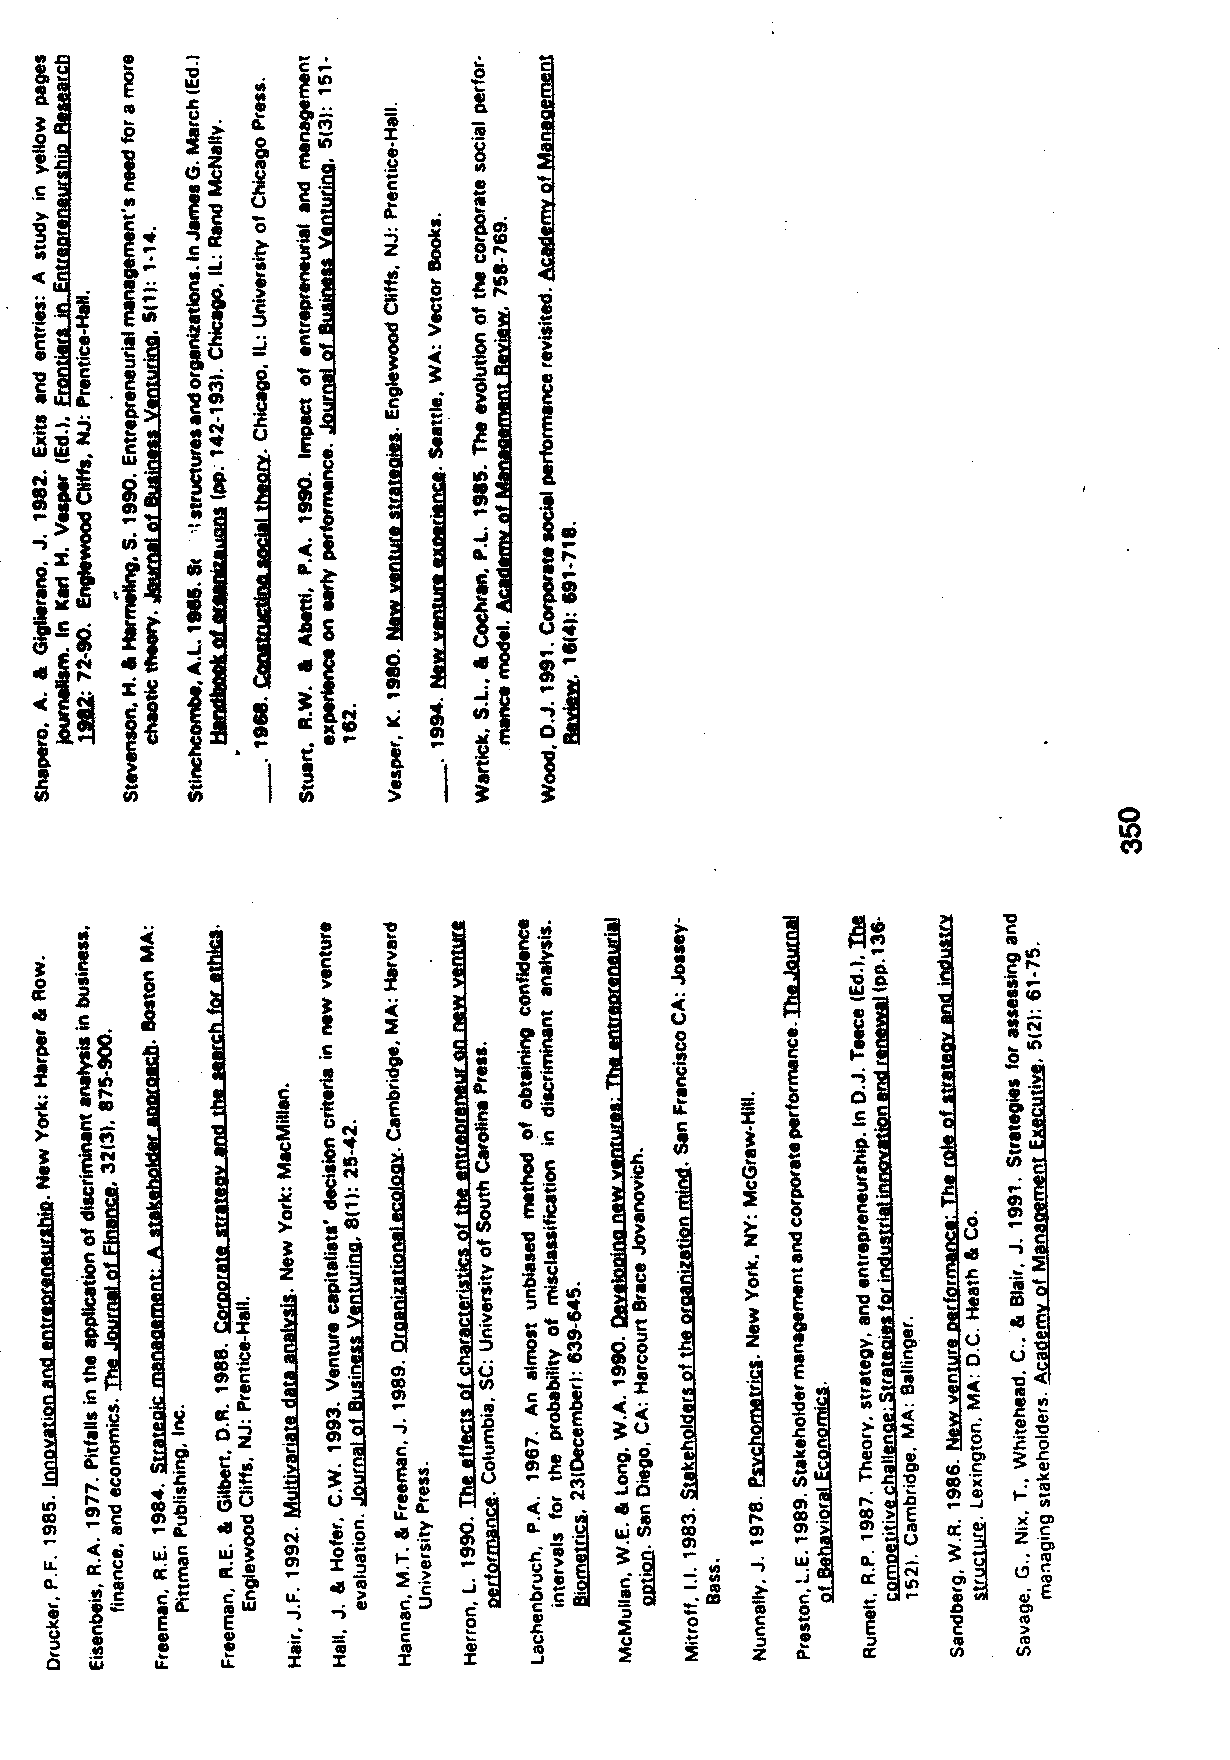

Mitchell, R.K. (1994). Stakeholder theory and liabilities of newness in new ventures. International Association for Business and Society 1994 Proceedings: 345-350, Hilton Head, S.C., March, 1994; and subsequently presented by invitation at the Second Annual Conference on Stakeholder Theory, Toronto, Ontario, July, 1994.

