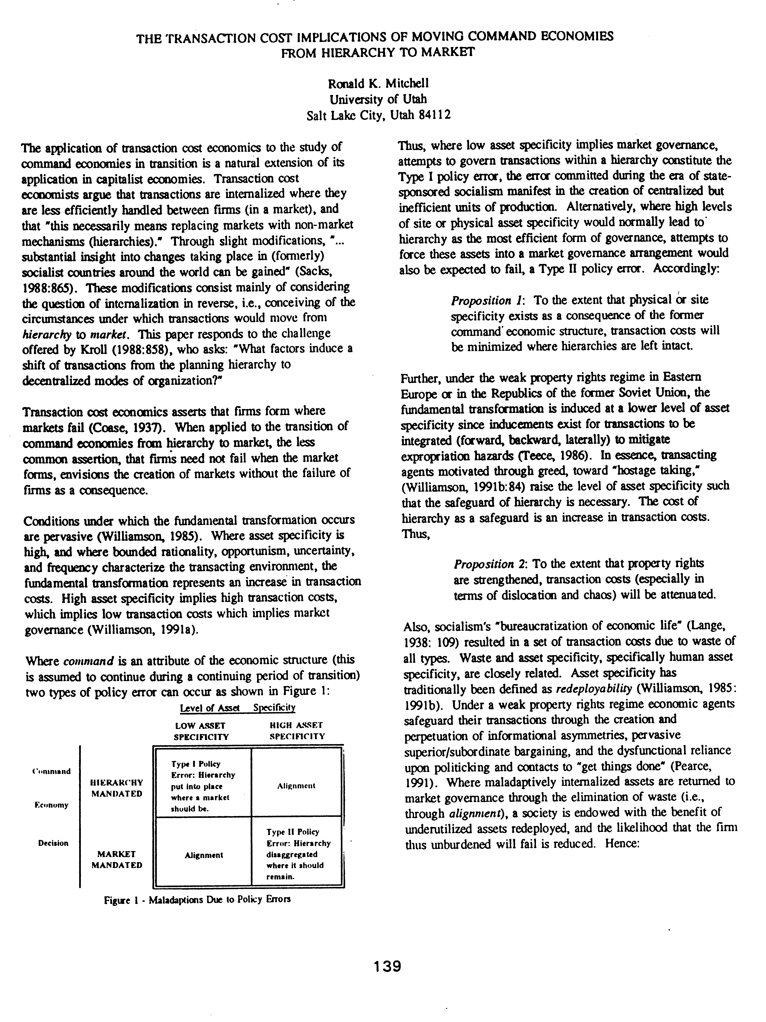
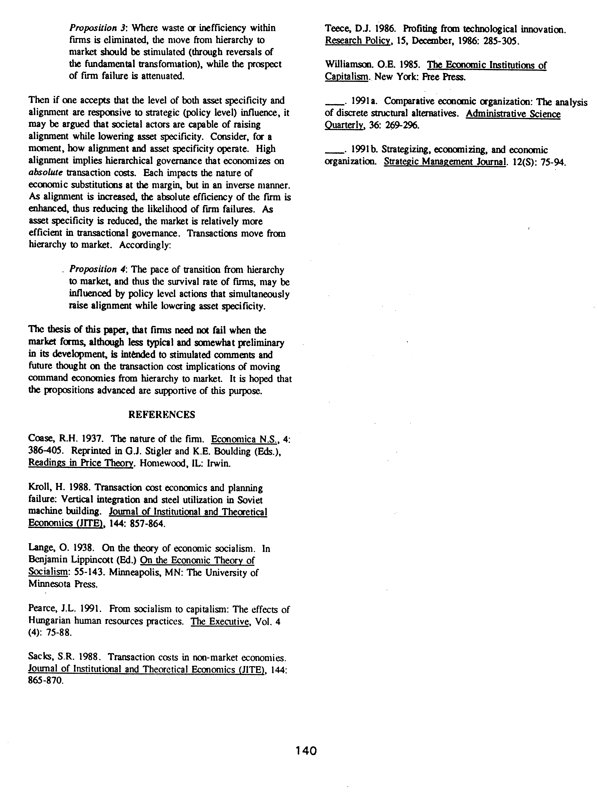
Mitchell, R.K. (1994). The transaction cost implications of moving command economies from hierarchy to market. Proceedings of the International Federation of Scholarly Associations of Management 1994 Annual Meeting: 139-140. Dallas TX, August 1994.

